Status update
I started with trying to improve the simplest predicted outcome, binary prediction of normal or malnourished (either SAM or MAM). Overall, I’ve not been able to improve on the unsatisfactory performance of the original MERON model.

Baseline (original MERON model)
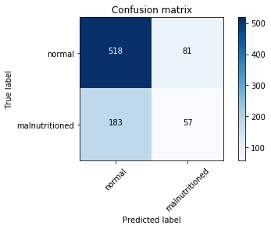
Accuracy score: 0.649583
Precision: .4
Recall: .225
F1 score: 0.377119
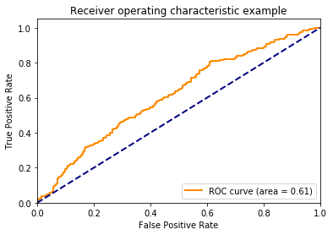

Best

Models I’ve tried
Traditional Machine Learning Models:
- Random Forest
- Gradient Boosting
- Logistic Regression
Deep Learning Models:
- Vision Transformer (ViT)
- ResNet50-based approach
Neural Network Variations:
- Multiple neural network architectures
Multimodal Fusion:
- Attention ResNet50 features + facial landmarks as features
- Neural network with attention heads

